KB61 – Repost Line Items

Functionality
A Reposting line item enables you to correct posting errors of costs originating from an FI document. The FI document remains the same and you will still be able to track the original posting from Financial Accounting (FI) through to the reposting in Controlling.

Scenario
In the following example the incorrect cost center has been charged for electricity. This will be reposted to the correct cost center. Only a new CO document is created. The FI document remains the same.

Requirements
The costs must have been posted through an FI document (accounting document).

Menu Path | Accounting → Controlling → Cost Center Accounting → Actual Postings → Repost Line Items → KB61 - Enter
Transaction Code | KB61

SAP Easy Access

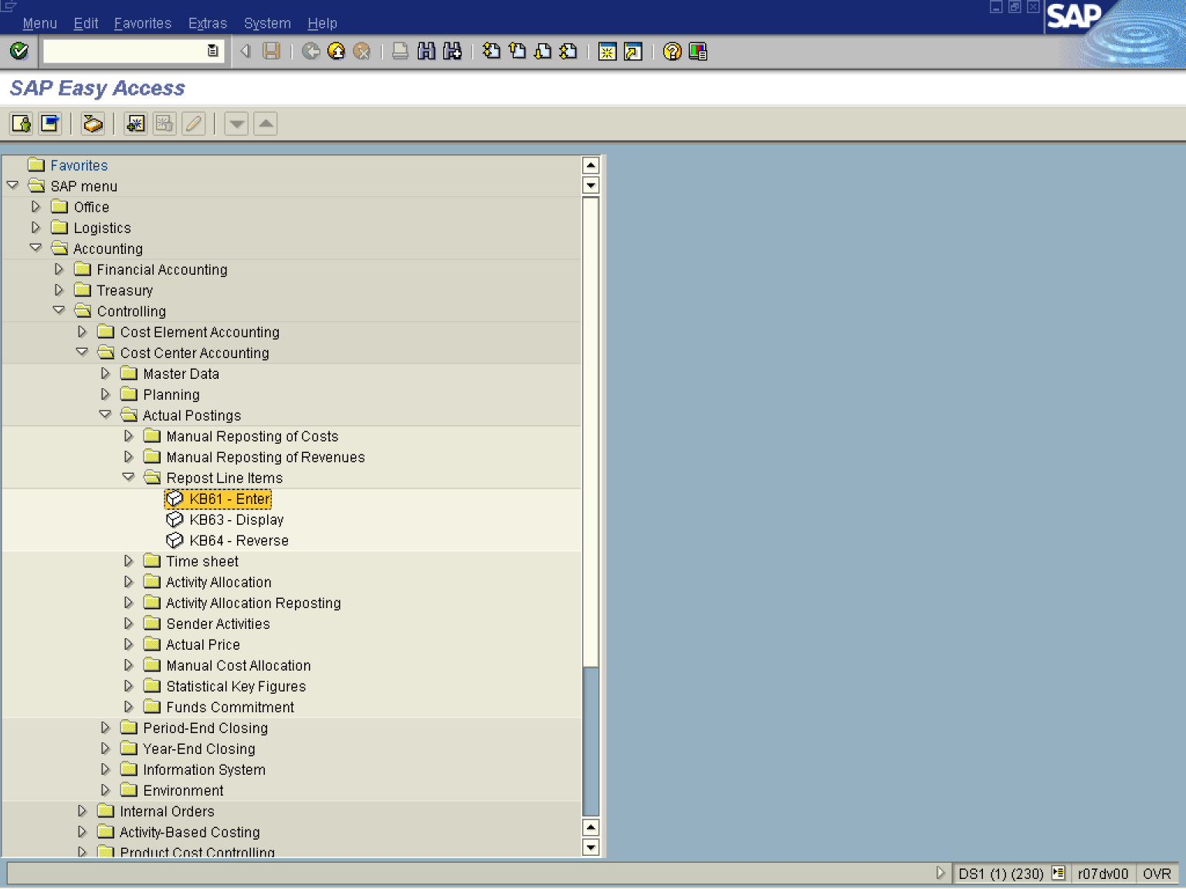

1. Double Click on KB61 - Enter

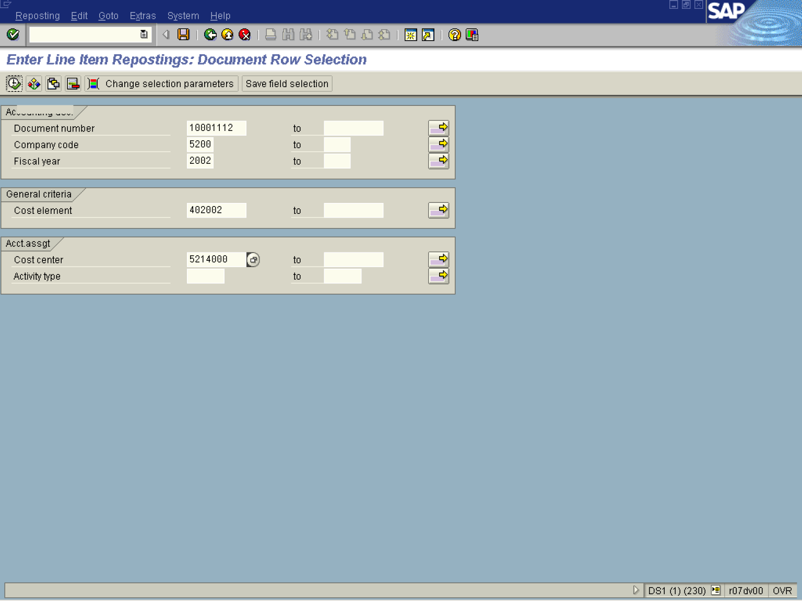
2. Update the following fields:

Field Name | Description | Values
Document number | Number of the SAP R/3 document that is internally assigned by SAP R/3 when certain transactions are completed | Example: 10001112
Company code | Code identifying the company purchasing the material | Example: 5200
Fiscal year | Period, 12 months as a rule, for which the company is to create its inventory and balance sheet. | Example: 2002
Cost element | Items in a chart of accounts that are relevant to cost, are referred to as cost elements. | Example: 402002
Cost center | Code identifying an organizational unit to which costs or assets are assigned | Example: 5214000
3. Click Enter to validate your entries.
4. Click Execute

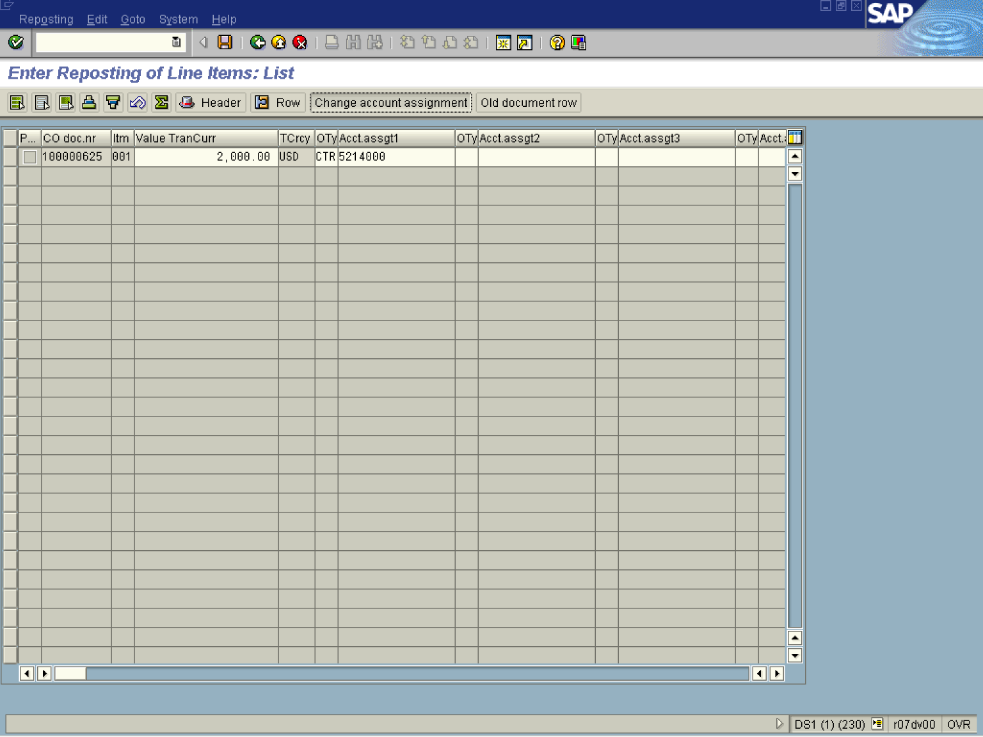
5. Click Change account assignment .

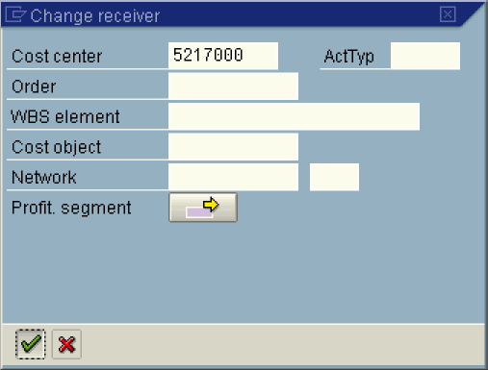
Note: Here you specify the new receiver of the cost. In this example a new cost center will receive the cost.
6. Update the following fields:

Field Name | Description | Values
Cost center | Code identifying an organizational unit to which costs or assets are assigned | Example: 5217000

7. Click Enter

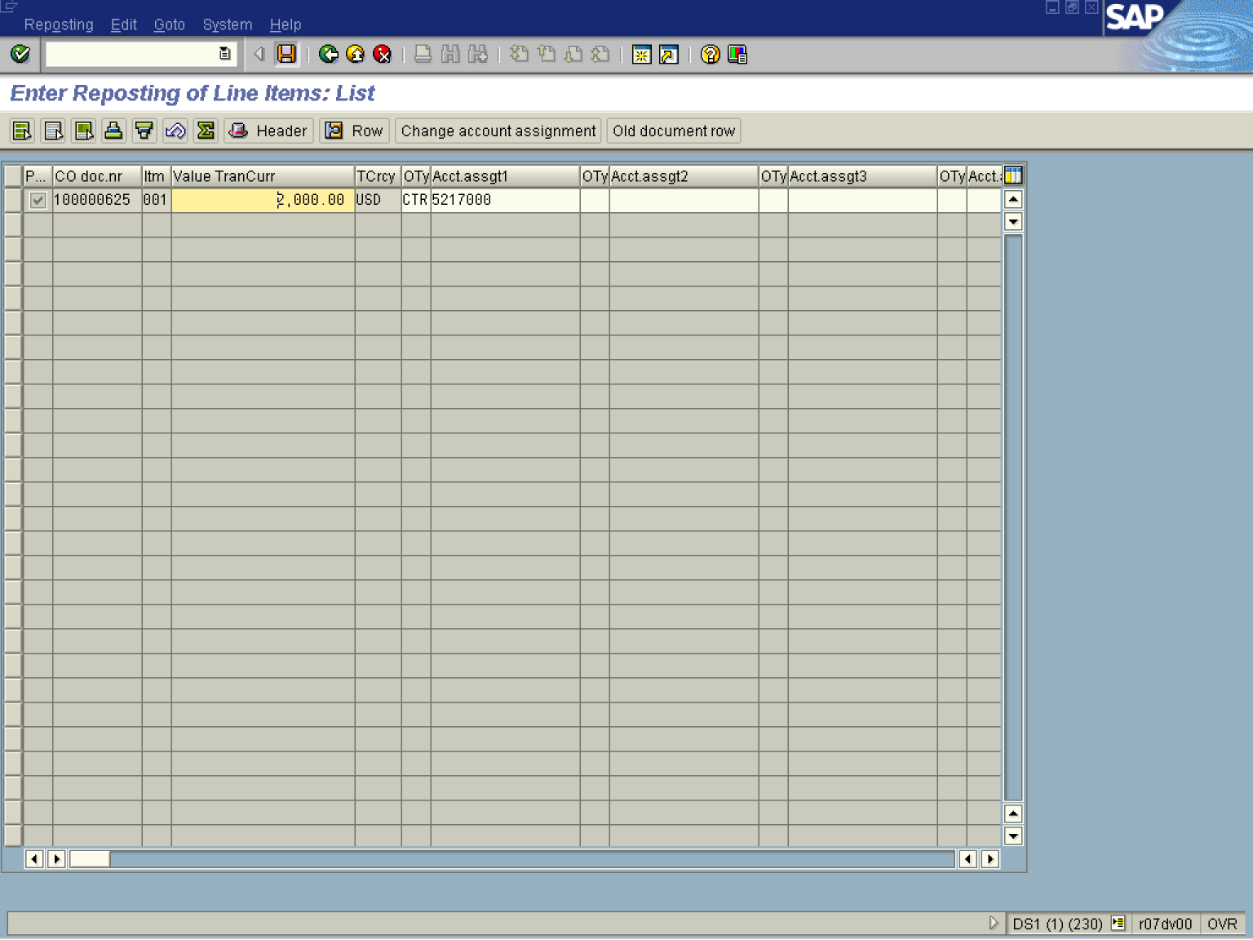

8. Click Save .

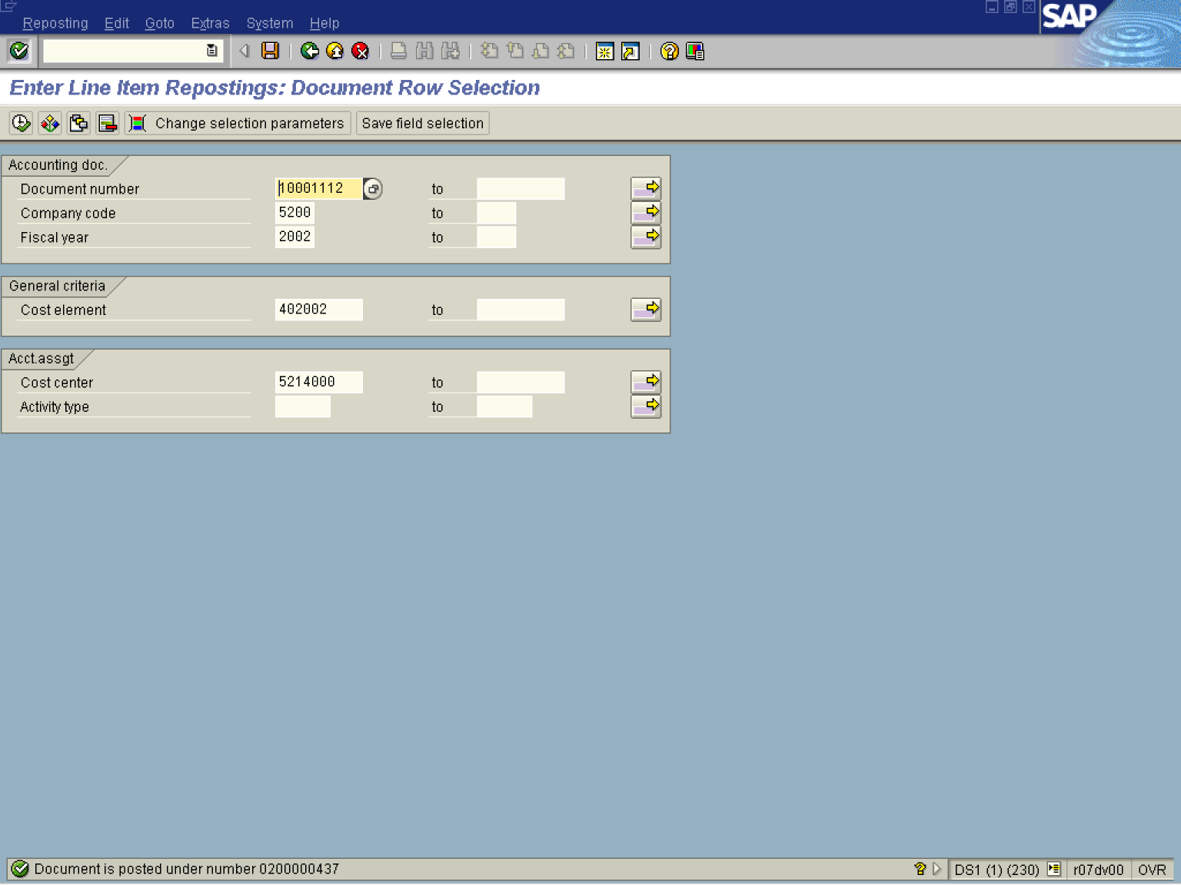

Remember that this transaction DOES NOT update the financial document ONLY the controlling one.

